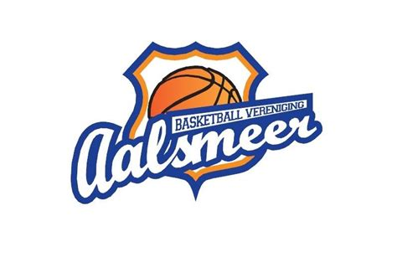

Trainerscursus BV Aalsmeer 2022
Kees en Meindert Buskermolen

Verdedigen.
Grofweg zijn er 2 manieren van verdedigen, zone en man-to-man. De manier waarop je ze uitvoert varieert statisch of pressie.
Ook zijn er erg interessante combinaties van beiden zoals box-and-one en triangle-and-two.
Elke balsport kent dit onderscheid in zoneverdediging en mandekking. Soms hangt het de sport of het speelveld af wat de meest voorkomende en gekozen vorm is.
Handbal speelt overwegend zone (rondom de cirkel), korfbal veelal man-to-man omdat men snel en goed kan mikken, voetbal meestal zone, behalve als je tegen Ibrahimovich of Ronaldo speelt waar nog wel eens “een mannetje opgezet wordt.

Bij basketbal zie je op het hoogste niveau bijna altijd mtm hoewel ook in de NBA een kentering te zien is sinds het toegestaan is om zone te spelen. Als je geroutineerde spelers hebt kun je de meeste zones makkelijk uit elkaar spelen en voor je beste schutter vrije schotkansen creëren.

Voordelen van een zone-verdediging
- Je maakt meestal minder fouten, je kunt sommige spelers sparen als ze in foutenlast zijn
- Ook geschikt voor minder snelle spelers, niet alle teams beschikken over snelle goede mtm-verdedigers
- Flexibel je kunt makkelijker variëren
- De aanvallen tegen een zone nemen meer tijd in beslag, je kunt het tempo in de wedstrijd bepalen (24-s-regel)
- Goed passen is een kunst veel ploegen kunnen die niet uitvoeren
- Er zijn niet zo veel spelletjes tegen een zone
- Je kunt je een beetje verschuilen in een zone, je wordt minder snel moe
- Je krijgt bijna nooit een lay-up tegen
- De tegenstander moet goed kunnen schieten om een zone te verslaan
- Het kunnen switchen tussen aanvallen tegen een zone en mtm is op zich al lastig
- Als je terugvalt vanuit een full court of half court press is het organisatorisch makkelijker om in een zone terug te vallen

Nadelen van een zone-verdediging
- Soms slechte verdediging tegen driepuntschutters
- Daagt (jeugd)spelers minder uit
- Rebounden is lastiger, wie ga je uitboxen?
- Bij scorende tegenstander is de verantwoordelijkheid moeilijker aan te wijzen

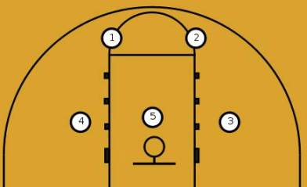 2-3 zone
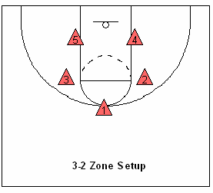3-2 zone
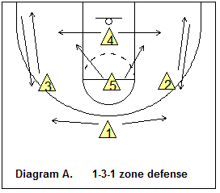1-3-1 zone

Opdrachten
- Teken de zones waar de spelers verantwoordelijk voor zijn in de plaatjes hiernaast.
- Aan welke eigenschappen moet een speler voldoen die op positie 1 in de 1-3-1 zone speelt.
- Aan welke eigenschappen moet een speler voldoen die op positie 4 in de 1-3-1 zone speelt.
- Aan welke eigenschappen moet een speler voldoen die op positie 5 in de 3-2 zone speelt.
- Aan welke eigenschappen moet een speler voldoen die op positie 1 of 2 in de 2-3 zone speelt.
- Maak een opstelling voor je team in een 2-3 zone en leg uit waarom je spelers inzet op welke positie.
- Maak een opstelling voor je team in een 1-3-1 zone en leg uit waarom je spelers inzet op welke positie.

Man to man defense

Voordelen
- Iedere speler moet dezelfde principes kennen, goed voor met name jeugdspelers
- Je kunt het op meerdere manieren inzetten afhankelijk van je tegenstander
- Goede voorbereiding voor de rest van je carriere

Nadelen
1. er is veel te leren
2. om het goed te leren, is er veel tijd en oefenen nodig –
3. Zwakke spelers worden ontmaskerd

Uitleg
In een mtm verdediging heb je drie rollen.
1. On-ball defense
2. Deny defense
3. Help defense
Om goed mtm te kunnen verdedigen moet een speller al deze rollen herkennen en kunnen uitvoeren. Je bent in een mtm altijd een onderdeel van een keten. Die keten is zo sterk als de zwakste schakel. Als je niet goed in positie staat is dat funest.
Regels voor de MTM-verdediging
- Heb je man onder controle
- Als je hem toch laat passeren moeten we iets organiseren als help-defense.
- Laat je aanvaller nooit voor je langs door de verdediging snijden
Als de bal gepasst wordt of van plaats verandert, beweeg jij als verdediger altijd. Neem een nieuwe positie in die past bij de dreiging.
The traditional man-to-man defense is by far the most common defense in the game of basketball today.
This is especially true as players progress to a higher level of competition. In fact, due to the great outside shooting of professional players, every NBA team almost exclusively plays man-to-man defense.
The man-to-man defense involves all 5 defensive players on the court being allocated one opposition player who they’re accountable for defending whenever they’re on defense.
Of course, there will be times when players switch opponents or help each other on defense, but for the most part, each player is responsible for one player from the opposition.
Learning to be a great man-to-man defender is perhaps the most important skill for a player to learn during their years of youth basketball.
No matter what defense a player goes on to play at the next level or on another team, the skills they learn playing man-to-man defense will transfer. Unfortunately, the same can’t be said for players that solely learn zone defense.
If you’re coaching youth basketball, taking the time to teach your team man-to-man defense will go a long way to preparing them for the next level.

Hoe beslis je als coach wat je gaat doen in een MTM defense.
Stappenplannetjes
- De bedoeling is dat iedere verdediger zijn aanvaller uitschakelt.
- Dat is niet altijd het geval, de aanvaller heeft tenminste 0,2 seconde voorsprong. Dat is vaak genoeg.
- Hulpmiddel 1: Geef je tegenstander altijd zijn zwakke hand. De meest simpele oplossing. Kan ongelofelijk goed helpen. (Bijna) iedereen heeft een voorkeurhand om te dribbelen. Helaas zie je het heel weinig toegepast.
- Hulpmiddel 2: Gebruik de zij- of achterlijn om je te helpen.
- Hulpmiddel 3: Stuur je aanvaller naar een medespeler die je kan helpen. Help-defense.

Wie komt er helpen:
- Optie 1: De dichtstbijzijnde speler moet opletten en de aanvaller die passeert oppakken;
- Als er dan een pass komt naar de vrijkomende speler die alle ballen raak schiet, gaat dat ook niet.
- Optie 2: De tweede man van achteruit is help-defense. Ook niet fijn want diens aanvaller kan dan op de baseline vrijkomen.

Deception is the name of the game (Bob Couzy).
- Help hoeft niet altijd help te worden, dreigen is soms al genoeg. Een handje aan de helpkant laten zien dat daar een help defense staat.
- Help and recover (ook bij pick and roll) even uitstappen als de aanvaller dreigt te passeren of echt passeert en meteen weer terug naar je eigen man. Dan voorkom je de pass en het schot van de driepuntschutter.

Vragen / opdrachten
- Hoe zet je je spelers neer wanneer je full denial mtm defense speelt. De aanval speelt hier een 1-2-2 en 2-3 aanval
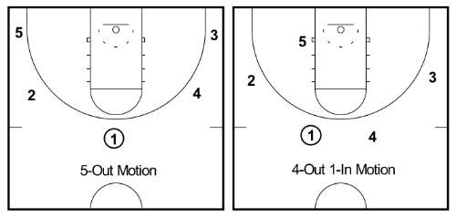

- Teken de positieverandering van der spelers wanneer de bal naar speler 2 wordt gepasst. Nog steeds full denial.
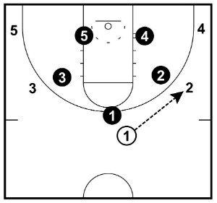

- Teken in de volgende tekening de stand van de armen en van de voeten van de verdedigers.
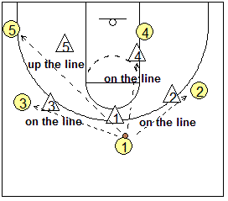

- Teken de nieuwe positie van de verdedigers wanneer de bal van 2 naar 4 wordt gespeeld. Aanname 1= je geeft je aanvaller altijd de baseline als optie.
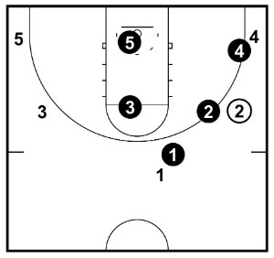

- Teken de nieuwe positie van de verdedigers wanneer de bal van 2 naar 4 wordt gespeeld. Aanname 2= je kunt rekenen op help in het midden.

- Teken de positie van de verdedigers wanneer de bal van 2 naar 5 wordt gespeeld.

Bijlage 1
1-3-1 zone uitgebreid
The 1-3-1 zone is an effective defense that can be used in the half or full court. It can be run as a trapping defense, soft denial (to force skip passes), or packed in to force teams into poor outside shots.
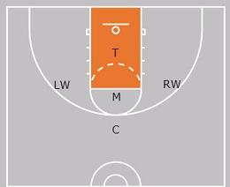
Some coaches use the 1-3-1 as a defense to switch things up, while others will use it as their primary defensive scheme.
The basic and traditional alignment is with the chaser (C) at the top, left wing (LW), right wing (RW), middle (M), and the tail (T) ready to cover the corners.
Below we’ll get into more detail sharing the 1-3-1 coverages, rotations, key teaching points, variations, drills, and more.

Why is the 1-3-1 Zone Effective?
The 1-3-1 defense offers a number of advantages that you don’t find in other defenses...
1. It’s strong in the middle of the floor. Three defenders are always guarding against penetration into the lane. The 1-3-1 defense makes it difficult to enter the ball into the post while providing excellent coverage of the 3-point line.
2. It has fewer moving parts than most zone defenses. Compared to other zone defenses, there are fewer “transitional defenders” (players who have to cover multiple areas).
3. It is the most versatile of all zones. With slight adjustments, the 1-3-1 zone can be played with varying pressure points at all levels of the court.
4. It lends itself to multiple adjustments and coverages within its basic structure. We run a number of very simple adjustments and coverages that both frustrate offenses and allow us to take away strengths.
5. There are few offenses designed specifically to attack the 1-3-1 Zone. Most “zone offenses” are designed to attack 2-3 and 1-2-2 defenses. You just don’t see offenses designed to work against the 1-3-1. You generally see some quick hitters plays designed for the 1-3-1. And those are easily shut down after you see them for a few possessions.
6. It is not as common as other zone defenses. Few college teams run the 1-3-1 zone, and as a result, you don’t see many youth and high school teams run the 1-3-1. As such, the uniqueness of the 1-3-1 provides an advantage against teams that do not play against it very often.
7. It can be effective regardless of your personnel. We have experienced great success with this defense with teams that were short or tall, quick or slow. For coaches who do not have the luxury of recruiting to fit their defense, the 31 Defense can be effective regardless of how your talent may fluctuate from season-to-season.
8. It takes away the ball reversal and passing angles. The shape of the zone is naturally suited to take away ball reversals and perimeter passes. This frustrates players and slows ball movement. Almost all offenses use ball reversals to create gaps and scoring opportunities. The 1-3-1 defense makes the ball reversal very difficult and as a result, most offenses are stagnant and have trouble getting into a rhythm against a good 1-3-1 defense.

Disadvantages / Cons of 1-3-1 Defense
No defense is perfect. There are some disadvantages of the 1-3-1 to consider:
- It’s not the best choice for player development with young teams. At the youth level, you can have a lot of success just by putting players in a 1-3-1 formation, getting their hands up, and having them play aggressive. However these players are not learning good defensive habits or good fundamentals. You can read more about the subject in this article where we recommend youth teams primarily play man to man defense.
- The corner can be susceptible to outside shots if you do not teach your players the proper coverages.
- The low post can be open if you do not teach your players to proper coverages.
- The defense can be susceptible to offensive rebounds and you need to spend time teaching your players how to rebound out of the zone.
Other than the youth development concerns mentioned, there really are not disadvantages. If you teach it the right way, there really are not weaknesses in the zone… just some areas you need to address as you implement the defense.
How It Works - Basic Overview
Court Geography
In order to help our players better understand their priorities defensively, we have certain terminology we use to define areas of the court.
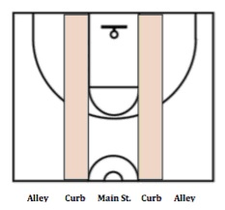
Main Street – The middle of the court between the lane lines extended from baseline to the half court line. A key focus for us defensively is to keep the ball out of Main Street.
Curbs – A four-foot area from the lane lines toward the sideline extending from baseline to half court line (see shaded area above).
Alleys – The area from curb to sideline, extending from the baseline to the half court line.

Cardinal Tenets Of The 31 Defense
Below is a list of tenets, or principles, that are key to making the 31 Defense work effectively.
1. Pressure the ball to make passing difficult. The defense is built on pressuring the basketball. We want to take away vision and contest every pass made by the offense. Defenders should be in a great stance to harass the ball-handler at all times – forcing soft lob passes over the top or bounce passes. We want players to anticipate and be in position to intercept passes. Our players must be positioned properly to prevent reversal passes.
2. Squeeze the seams. We want to stop dribble penetration by squeezing the gaps in the zone to prevent the ball from getting into Main Street.
3. Own Main Street. We must keep the ball out of the middle of the floor. Main Street is defined as the area from the defensive pick-up point to the basket between the lane lines extended. All defenders should be aware of ball movement so that Main Street is controlled. We constantly tell our players, “No Main Street!”
4. Maintain the shape of the zone. Many zone offenses attempt to distort the zone through their spacing, cutting, and by overloading one particular area of the zone. Therefore, it’s important that we do not allow there to be too much distance between our defenders. The defense should move in unison, as though they are “tied together on a rope,” and must move on the flight of the ball. We do not want the zone to be distorted in such a way that gaps are exposed between defenders that can be exploited by the offense. We want all defensive movement to occur while the ball is in the air so that defenders are in proper position on the catch.
5. Contest EVERY shot. Research has proven that contested shots are going to dramatically increase the effectiveness of your defense. Open shots are going to be made at a higher percentage than those that are contested; therefore we want to make them miss by contesting every shot!
6. Finish every possession by filling the Percentage Rebounding Areas. Players should form a triangle around the rim and go after the ball with reckless abandon.
7. Play great defense WITHOUT FOULING. We want to play with great intensity and effort while keeping our opponent off the free throw line. We do not want the other team to get into the bonus, especially in the first half.

Who Might Use The 1-3-1?
Youth teams (12 years old and younger) should avoid the 1-3-1 zone. Only advanced youth teams that already have learned strong man to man fundamentals should consider this 1-3-1.
Any college, high school, or advanced middle school team can see a lot of success using the 1-3-1 defense. It’s a proven defense and a great option for anyone looking for an “equalizer” or to gain a defensive advantage.
You can use this as your primary defense or as a change up defense.

Variations of 1-3-1
There are a number of variations you can run out of the 1-3-1 defense. In this video, you can see the automatic butterfly coverage when offenses throw “ping pong” passes:

Forty year college & high school coaching veteran Will Rey explains an automatic adjustment your 1-3-1 defense should make to prevent the offense from throwing the ball back and forth between two players (ping-pong).
A "Butterfly" adjustment is when the defensive player on the wing gets between the ball and the offensive player on the wing, just as you see in the video. This makes a pass back to the wing difficult to make, and prevents the offense from just throwing the ball back and forth.
Other variations of the 1-3-1 include:
- Plug (middle man plugs the high post)
- Soft denial (force high/slow skip passes)
- Trapping
- Alternate high / low post coverages
- Extending the defense to half or full court
For a thorough explanation of the 1-3-1 defense, the variations, and how to teach it step-by-step... watch Will Rey’s 31 Defense - The Disruptive 1-3-1 Zone Defense.

1-3-1 Half Court Trapping
College & high school coaching veteran Will Rey explains when and how your 1-3-1 zone defense should automatically trap.

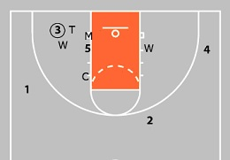
In the clip above, Coach Rey explains when your defense should automatically trap, or blitz out of the basic 'PLUG' coverage in his 1-3-1 zone defense.
The automatic trap comes each time a player drives baseline, with the tail and the wing of the defense trapping. Since the two defenders are trapping, the rest of the defense is in a 'pack the lane' coverage.
It's important for the tail to cut off the baseline drive and for the wing to make a hard trap, or the defense can break down.

1-3-1 Zone Press - Extending Pressure
41 Defense - Full Court
Our basic 31 Defense is a quarter court defense that can be extended to half court should the Chaser choose to pick the ball up near the half court circle. However, we can also extend the 1-3-1 defense 3/4 court or full court by running our “41 Defense.”
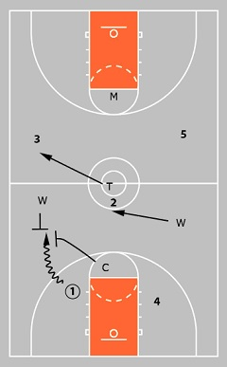
This diagram demonstrates how we extend our defense into the backcourt in our 41 Defense.
The CHASER picks the ball up around the free throw line in the backcourt. He should exert maximum pressure while ushering the ball toward the sideline.
The BALL SIDE WING traps the ball with the Chaser along the sideline.
The WEAK SIDE WING rotates to take away the middle of the floor.
One alteration we make in the 41 Defense is to invert our Middle and Tail. The MIDDLE becomes the basket protector at the back end of the defense.
The TAIL becomes an interceptor on the ball side of the court to take away any passes up the sideline.
The only pass we allow is the reversal pass to the other player in the backcourt (4).
In our regular 41 Defense, we will trap one time before sprinting back into our regular 31 Defense. If we are in a late game situation that requires constant pressure, we will run “41 Defense ALL OVER” which means we continue to trap every pass.

51 Defense - Pressure Inbounds
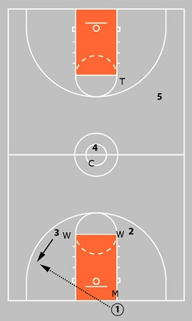
The diagrams illustrate how we extend full court to pressure the inbound pass in our “51 Defense.”
The MIDDLE plays on the basketball making it difficult for the inbounder to see and pass.
The WINGS move up to deny the two nearest receivers.
The CHASER plays the middle of the floor.
The TAIL is the basket protector in the back of the press.
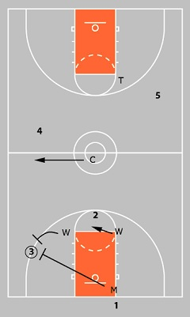
When the ball is inbounded, the MIDDLE and BALL SIDE WING trap the ball aggressively.
The CHASER moves to take away any pass up the sideline.
The WEAK SIDE WING takes away anything to the middle of the floor.
The TAIL guards the goal.
Similar to the 41 Defense, we want one good trap before sprinting back into our regular 31 Defense. However, if the game requires constant pressure then we will be in “51 Defense ALL OVER” to trap the ball with the two closest defenders.

1-3-1 Zone Defense Drills
Here are a few drills to help isolate the movement of the various positions on the floor.
The Spine Drill

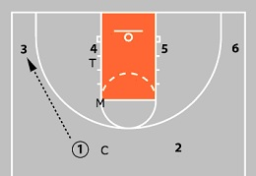
This drill isolates the backbone of the defense: the CHASER, the MIDDLE, and the TAIL. These three must move in unison as the ball moves about the perimeter.
Four players are positioned around the perimeter with two additional players on the low blocks. The perimeter players move the ball randomly while the defenders practice their coverage responsibilities.
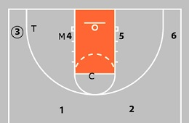
The Pistons Drills

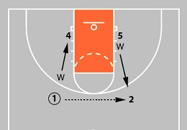
This drill isolates the coverage responsibilities of the two WINGS.
The drill begins with two players located in the guard lanes, and two additional players stationed on the low blocks.
As the ball is passed from guard to guard, the Wings follow their most basic rule: As the ball comes to my side of the floor I come forward, as the ball goes away from me, I go to cover the block.
The perimeter plays may attempt to throw entry passes to the opposite post to test the Wing's ability to cover. The Wings should be coordinated in their movement and never side-by-side in this drill.
We do this drill for about 30 seconds for each set of Wings.

Defending BLOBs with the 1-3-1
How do you defend baseline out of bounds plays?
There are several ways to defend baseline out of bounds situations...
Stay in 1-3-1 Defense
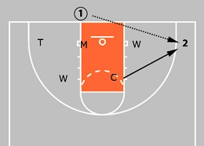
The first option is to continue to stay in the 1-3-1 Zone. When the ball is taken out on the baseline, the coverage responsibilities of each position are as follows:
TAIL - Covers the ball side baseline area to the corner.
MIDDLE - Covers the ball side block.
BACK SIDE WING - Covers the weak side block.
BALL SIDE WING - Covers an area above and between the Middle and Tail.
CHASER - Covers an area above and between the Middle and Back Side Wing. The Chaser is also responsible for any catch in the weak side corner.
Once the ball is passed to the top, the defense returns to its normal 1-3-1 positions.

Start in 2-3 Zone
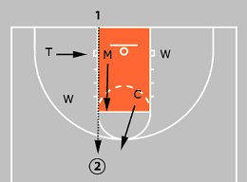
Over the years we have also defended baseline out of bounds plays by playing our 2-3 Zone in the same alignment as illustrated above. If the ball is passed to either corner, we stay in our 2-3 Zone for the rest of the possession. If the ball is thrown above the free throw line then we transition into our 1-3-1 Zone.
The primary factor we consider when deciding whether to stay in the 1-3-1 Zone is our personnel. When our teams are bigger, and take up more room on the floor, we like to stay in the 1-3-1 Zone as much as possible. At other times, when we are a bit smaller, we have found that the 2-3 Zone provides better coverage of the basket area particularly when the ball is being inbounded on the baseline.

Blitz the First Pass
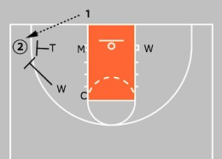
We align our defense in the same manner as above (1-3-1 formation). However, when the ball is inbounded we may run an immediate BLITZ with our Pack the Lane coverage away from the ball.
The Tail and Ball Side Wing converge to trap the ball on the entry to the corner. Once the ball rotates back to the top, we return to our standard 1-3-1 defense.
THE LOS ANGELES Lakers entered the fourth quarter of Game 3 of the Western Conference finals trailing the Denver Nuggets by 18 points when Lakers coach Frank Vogel called for a zone defense -- a strategic move NBA coaches once considered a last resort, but one that is becoming increasingly common this postseason.
The Lakers used their zone to rack up five steals in less than three minutes, cutting the lead down to as little as three points. And while the Nuggets recovered to win the game, the defensive switch nearly led to the second-biggest comeback of LeBron James' lengthy playoff career.
"As a coach, when your team gets down and you're looking for something to try to give your team a spark, you try to change the game," Vogel said. "Sometimes it's a lineup. Sometimes it's a coverage. Sometimes it's zone defense, throwing it out there, just to break their rhythm a little bit.
"It doesn't always work. It did tonight."
- 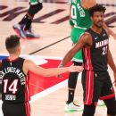

How the Heat's unsung heroes gave Miami a 3-1 lead
- 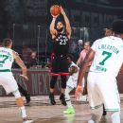

NBA playoff success has never been so dependent on 3s
In the ongoing battle between NBA offenses and defenses, offenses have dominated recently. The past two seasons have produced the most efficient offense on record behind ever-growing numbers of 3-point shots.
"I think that the offense changed drastically, and the defense stayed pretty much the same for a while," Toronto Raptors coach Nick Nurse said, "and now I think the defense is starting to have to adjust to such a different and drastic style of offensive play."
The heavy use of zones has been a key adjustment this postseason. And now the zone defense, once disdained, has the potential to reshape this year's NBA Finals.

AS RECENTLY AS two seasons ago, the NBA zone defense -- which has been allowed since 2001-02, when the league removed the "illegal defense" rule preventing its use -- had all but gone extinct.
After peaking at 3% usage during the 2009-10 season, zone was used for just 638 plays in 2017-18, 0.2% of all possessions, according to Synergy Sports data. That was the culmination of six seasons of decline after zone defenses were more common in the NBA from 2009 through 2012, highlighted by the Dallas Mavericks' zone helping them upset the heavily favored Big Three Miami Heat in the 2011 NBA Finals.
Seven years later, Miami played a key role in bringing the zone back in vogue.
On Dec. 20, 2018, the Heat used a zone defense to slow down reigning MVP James Harden in a nationally televised win over the Houston Rockets. Harden, who was amid a historic run of 32 consecutive games of scoring at least 30 points, went just 7-for-23 from the field against the unorthodox defense.

Playoff Basketball Battle

Answer questions on the NBA playoffs and compete for $30,000 of guaranteed prizes! Make Your Picks
Though Heat coach Erik Spoelstra dismissed the notion that there was any grand strategy behind turning to a zone a handful of games earlier -- "We did it because our man [defense] wasn't working," he said -- other coaches took notice of how much zone Miami was playing. The Heat used zone on more plays during the 2019-20 regular season, 802, than all 30 NBA teams combined in either 2016-17 or 2017-18. League-wide zone usage was up to 2.2% this season, its highest level since the lockout-shortened 2011-12 season.
While Miami didn't need to use its zone to beat either the Indiana Pacers or Milwaukee Bucks, it has been a key factor in the Heat's building a 3-1 series lead in the Eastern Conference finals heading into Friday's Game 5 against the Boston Celtics (8:30 p.m. ET on ESPN).
Other coaches have taken notice. "One of the best things you can do is learn from real good coaches," Utah Jazz coach Quin Snyder said. "And Erik is a terrific coach, so it calls your attention to it, and then you have to figure out: Is this applicable to our team in some way?"
One big reason coaches have traditionally shunned the zone is that NBA players can shoot right over the top of it, but modern NBA zone defense is no longer so vulnerable to outside shooting.
"Teams have tinkered with zone rules and tinkered around the three-second rule for the middle man, so it's not your typical college 2-3 or 3-2 zone anymore," said Detroit Pistons coach Dwane Casey, who was the architect of the Mavs' 2011 defense.
"The way teams have bastardized the zone so much and tinkered with the zone, it's really a glorified switch."

2020 NBA Finals

The Los Angeles Lakers defeated the Miami Heat 4-2 in the 2020 NBA Finals to claim their 17th championship. Check out all our Finals coverage here.
• Shelburne: Inside the Lakers' title run
• Lowe: The GOAT debate is different now
• LeBron's Laker Year 2 ends with a title
• The final days of the NBA's bubble
This helps explain why the Heat's zone was effective against Harden. Modern offensive superstars such as Harden all but demand that man-to-man defenses switch pick-and-rolls to keep up, which puts their defenders in uncomfortable positions -- guards defending post-ups and big men defending one-on-one on the perimeter. In a zone, those defenders stay where their coach wants them.
Spoelstra has also changed where those players are by putting two athletic forwards on the perimeter in the Heat's 2-3 zones, with the team's smaller guards playing on the wings in the back line. That has made Miami's zone defense more difficult for Boston to attack.
Snyder borrowed that innovation when Utah implemented a zone defense at midseason.
"Having more length at the top, that player has an opportunity to impact the offense two different ways," Snyder explained. "From the corner, there's one pass, essentially, one direction that you can go. From the top, a lot of times there's two different directions that someone can pass."
Despite their evolution, zones remain most vulnerable beyond the arc. So, their rise also required the NBA's shot math to change.

THE DECLINE IN zone defense over the past decade coincided with the NBA's love affair with the 3-pointer. But now, even with 3-pointers being attempted at record rates, zone is back on the rise.
"It's such an interesting contradiction," Washington Wizards coach Scott Brooks said. "We are shooting 3s more than ever, so why would you play a zone?"
When the Mavericks used zone in the 2011 NBA Finals with Casey as their defensive coordinator, they were exposing a Miami weakness. At that point, before adding Shane Battier and unleashing Chris Bosh as a 3-point shooter, the Heat had a shortage of shooting.
Now, every team looks to have as much shooting on the floor as possible. Yet, there's a paradox to all these 3-pointers: In a counterintuitive twist, they've made controlling the area around the basket more important for opposition defenses.
There are two factors at play. First, five-out lineups in which every player on the court can shoot 3s have made it hard for defenses to cover enough ground to load up the paint against players driving from the perimeter and also get out to shooters.
"I think it's either-or," said Casey, whose perspective is borne out by the data. "You're going to do one or the other. It's hard to do both."
Second, shots at the rim are simply more valuable. The average attempt in the restricted area was worth 1.27 points this season, as compared to 1.17 points for the average 3-point attempt from the corners and 1.05 points for 3-pointers taken from elsewhere on the court.
Because of that math, job No. 1 for a modern NBA defense is preventing opponents from getting to the rim, even more than preventing 3-pointers.
Among the NBA's top 10 defenses in 2019-20, just one team (the Philadelphia 76ers) ranked in the top eight in preventing 3-pointers. Conversely, four of the top 10 (including Milwaukee and Toronto) were among the eight teams that allowed the most 3-point attempts.
However, six of this year's top 10 defenses were in the top eight in preventing shots in the restricted area around the basket, per analysis of data from NBA Advanced Stats, and none in the bottom eight.
It's here where the zone shines. Per Second Spectrum tracking, teams shot 3s far more frequently against zones (53% of their shot attempts, as compared to 38% of shot attempts against man-to-man defense). But zone defenses dramatically reduced shots in the restricted area, from 26% of attempts against man-to-man to just 16% against zone.
The increased emphasis on protecting the rim, and the zone's effectiveness in doing so, has led three of the four teams in the conference finals to use zone this round. Only the Denver Nuggets, who are down 3-1 in the West finals, have yet to break it out.

UNLIKE IN COLLEGE basketball, where legendary coaches such as Syracuse's Jim Boeheim and retired longtime Temple coach John Chaney built their defenses around exclusive use of 2-3 zones, NBA teams have found it more effective as a counterpunch. Overall, Second Spectrum tracking shows zone defenses giving up slightly more points per possession (1.12) than man-to-man defenses (1.11).
"It's a different look," Vogel said. "Most zones in the NBA are not very good; there's a lot of holes in them and can be easily exploited. It doesn't always happen, but that's why most of the league does not play zone for long stretches."
Still, as Brooks notes, zones have value by taking offenses out of what they typically want to do.
"When you [face] a man-to-man defense, you can run a pattern," Brooks said. "You know that if they guard it this way, OK this will be open, and, if they guard it this way, [then] this will be open. So you have your check points as a player and as a coach.
"But in a zone, it's a little bit of organized chaos. You have gray areas. ... You have some concepts, but you really have to be free-flowing. You really have to have a really stronger-IQ basketball team to be able to attack it consistently."
No coach has made better use of zones to mix things up than Nurse, recently voted Coach of the Year. During last year's NBA Finals against an injury-depleted Golden State Warriors team, Nurse went to a zone defense typically seen in high school -- a box-and-one -- to thwart Warriors star Stephen Curry. He went back to it again during this year's Eastern Conference semifinals against Boston to try to slow down Kemba Walker after he tore apart Toronto's defense early in the series.
"I've coached in a lot of playoff games now, a lot of playoff series and a lot of NCAA tournament games," Celtics coach Brad Stevens said after Boston's Game 7 victory. "I'd say we saw more defenses and more stuff ... right when something worked, the next play it didn't work anymore. That's a credit to them."
After outlasting the Raptors, the Celtics have struggled against Miami's 2-3 zone in the conference finals. They've averaged just 1.04 points per possession on the 113 possessions marked by Second Spectrum data as against zone, down from 1.19 points per possession against man-to-man, while shooting 29% from 3-point range. In a series in which the Heat's three wins have come by a combined 11 points, those possessions loom large.
Between players getting more and more creative with the ball in their hands, an influx of quality shooters at every position on the court, and rules being created and enforced to aid offense, defenses are left in a nearly impossible spot. The goal isn't to take away everything from an offense, but to keep them from going to what it is they want to do most.
"It's going to be hard for defense to trump offense like it used to in the late '90s," former Philadelphia 76ers coach Brett Brown said earlier this year.
Still, that won't stop coaches from trying.
"The game has changed," Brooks said. "I think zone defense is going to be taking place more and there's going to be more creativity, and someone is going to come up with something that is totally different than the last guy."
“I thought zone was a weak man’s game,” Rivers said.
The Hall of Fame guard Gary Payton still does. Payton retired in 2007, but the smothering guard unforgettably known as “The Glove” remains a passionate critic of zones at the pro level — even though his son Gary Payton II of the Washington Wizards happens to play for the N.B.A. team using more zone than anyone (9.8 percent of the time, per Synergy).
“Trash,” Gary Payton said in a phone interview. “That’s a cop-out. Why do college teams go to a zone? Because they can’t guard anybody.”
The Wizards’ No. 30 defensive rating through Thursday (Washington was allowing 115.4 points per 100 possessions) appears to support Payton’s contention. Yet in Toronto, Coach Nick Nurse has a roster filled with elite defenders, which has encouraged Nurse to not only embrace zones but also experiment with a variety of defenses rarely seen at the pro level.
In one memorable Game 2 sequence of the 2019 N.B.A. finals, Nurse unleashed “box-and-one” coverage on Golden State’s Stephen Curry — four players in a square-shaped zone, with Fred VanVleet shadowing Curry as closely as possible.
As the league’s defending champion, Toronto has countered injuries to key figures such as Pascal Siakam, Marc Gasol and Kyle Lowry this season with half-court double-teaming of Houston’s James Harden, 1-2-1-1 zone pressing and more box-and-one that, according to conventional N.B.A. wisdom, should not work against most skilled offensive players on the planet.
The Raptors have also mixed in a good bit of 2-3 zone — two defenders at the top with a row of three behind them — in securing the No. 2 spot in defensive rating despite all of their health woes.
“I think we have seen that some of these other defenses have worked,” said Nurse, whose Raptors are on a surprising 53-win pace even after losing the finals M.V.P. Kawhi Leonard in free agency. “For parts of games, anyway.”
After Leonard’s arrival — along with the acquisition of Paul George to join the tenacious Patrick Beverley and mobile frontcourt players such as Montrezl Harrell, Maurice Harkless and JaMychal Green — Rivers decided that the Clippers’ roster composition compelled him to think more openly about zones.
“We have a switchable basketball team for the first time in my career,” Rivers said, referring to the ability of similarly sized players to easily switch onto a different offensive player in the midst of a possession.
The Clippers, as a result, have used zone looks on 4 percent of their defensive possessions, according to Second Spectrum, and, like Carlisle’s Mavericks, have held the opposition to less than a point per possession when in a zone setup.
Beverley has said that, despite his own Payton-like determination to harass other guards, he has no issues when Rivers calls for zones. He played for nearly four seasons in Europe before establishing himself in the N.B.A., and zone defense is much more prevalent in leagues overseas.
Rivers, though, admits he will sometimes refer to it as a “flex zone” — or “more of a switching defense than a zone” — to encourage player acceptance.
The potential payoff of a well-executed zone is clear, despite the vulnerabilities it exposes in terms of rebounding and surrendering open shots. A good zone, at least for a time, can create confusion, inspire hesitation and potentially dislodge offensive supernovas such as Harden and Curry from their comfort zones.
Thanks to a lack of dependable perimeter shooters around the All-Star big man Joel Embiid, no team faces more zones than the Philadelphia 76ers. The most notable culprit for inviting that strategy is Ben Simmons, Embiid’s fellow All-Star, who has attempted only five 3-pointers all season — sinking two after shooting 0-for-17 from deep over his first two N.B.A. seasons.
The Athletic reported in December that the Sixers saw a zone on 156 possessions in a three-game stretch against Miami, Dallas and Washington over a four-day span. According to Synergy Sports data used in the report, 21 of the league’s 30 teams faced fewer than 156 possessions of zone defense for the entire 2018-19 season.
“We’ve seen so much innovation and change offensively over the last five years,” Toronto’s Nurse said. “It only makes sense that teams are going to try things and look for things defensively to counter that.”
The limited practice time teams enjoy in the modern game makes it challenging for coaches to implement zone coverages, because they typically require additional preparation and increased communication among the defenders. But that didn’t stop the Los Angeles Lakers, No. 3 in the league in defensive rating, from springing a surprise on Carlisle’s Mavericks on Jan. 10.
In a move right out of the Mavericks’ playbook, with the former Dallas guard Jason Kidd now on the bench as an assistant to Lakers Coach Frank Vogel, Los Angeles used a zone for numerous possessions in the second quarter in an attempt to short-circuit the rising Dallas star Luka Doncic’s usual pick-and-roll effectiveness — and then fell back into man-to-man coverage as soon as the Mavericks made their first pass. It’s a ploy Dallas used frequently against LeBron James and the Miami Heat in the 2011 N.B.A. finals, in which the Mavericks upset Miami in six games.
But James was on the winning side this time, with the Lakers rolling up a 21-point lead in the first half in an eventual 129-114 road win despite the absence of an ailing Anthony Davis.
The Mavericks, to this day, believe they would not have won their lone championship without substantial doses of zone. For all the talk that N.B.A. shooters are simply too proficient for teams to stay in zones for long, Carlisle expects zone defense to continue its comeback in the second half of the season.
“It’s been very cyclical in the last eight or nine years,” Carlisle said. “But the teams that are using it are using it with effectiveness. And you have to prepare for it. If you’re not prepared for it, you’re going to be up against it.”

- .

